**QUIZ RESULTS**

**MODULE5: ENSEMBLE MODELS**

|  |  |  |  |  |
| --- | --- | --- | --- | --- |
| **No.** | **Quiz title** | **Completion Status** | **Score** | **Coursera link** |
| 1 | Module5_1_Bagging | Completed | 100% | [Quiz 1](https://www.coursera.org/learn/supervised-machine-learning-classification/assignment-submission/8ybJk/bagging/view-feedback) |
| 2 | Module5_2_Random Forest | Completed | 100% | [Quiz 2](https://www.coursera.org/learn/supervised-machine-learning-classification/assignment-submission/6sQf3/random-forest/view-feedback) |
| 3 | Module5_3_Bagging Labs | Completed | 100% | [Quiz 3](https://www.coursera.org/learn/supervised-machine-learning-classification/assignment-submission/sskrW/bagging-labs/view-feedback) |
| 4 | Module5_4_Boosting and Stacking | Completed | 100% | [Quiz 4](https://www.coursera.org/learn/supervised-machine-learning-classification/assignment-submission/7dIFV/boosting-and-stacking/view-feedback) |
| 5 | Module5_5_Boosting and Stacking Labs | Completed | 100% | [Quiz 5](https://www.coursera.org/learn/supervised-machine-learning-classification/assignment-submission/LplPF/boosting-and-stacking-labs/view-feedback) |
| 6 | Module5_6_Graded Quiz | Completed | 100% | [Quiz 6](https://www.coursera.org/learn/supervised-machine-learning-classification/assignment-submission/kvVLI/module-5-graded-quiz/view-feedback) |

# Module5_ Bagging

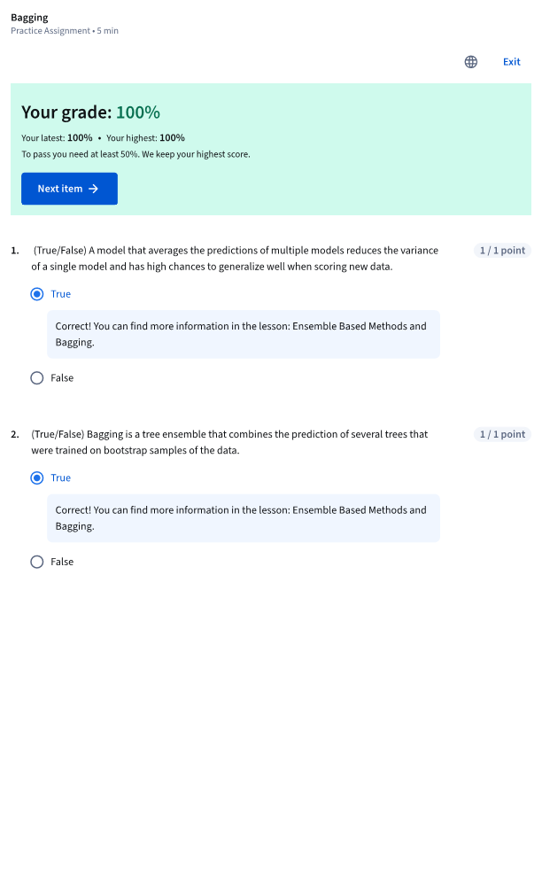

# Module5_ Random Forest

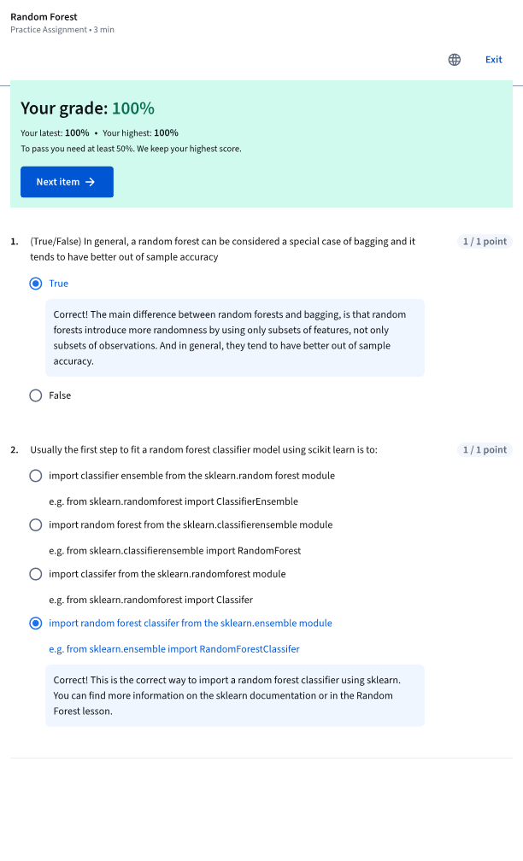

# Module5 _ Bagging Labs

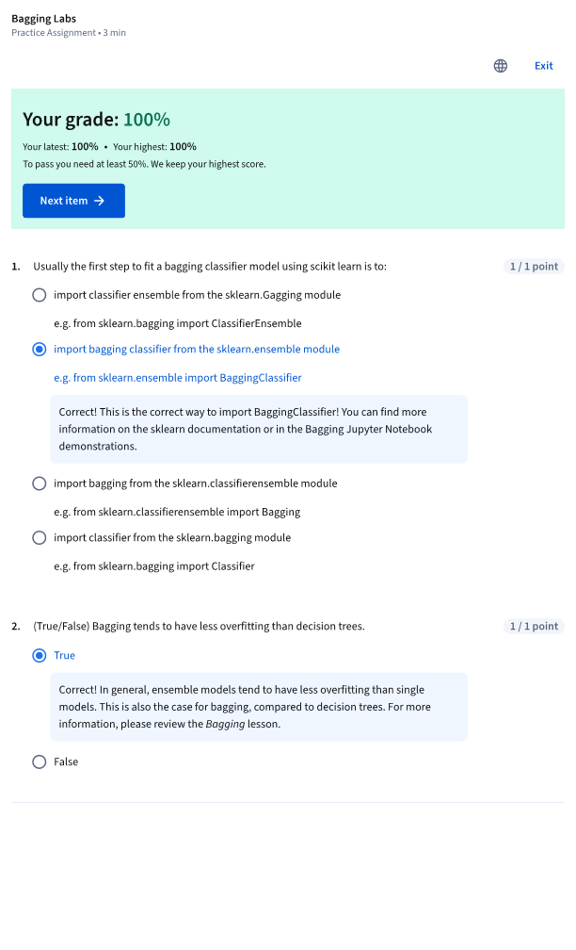

# Module5 _ Boosting and Stacking

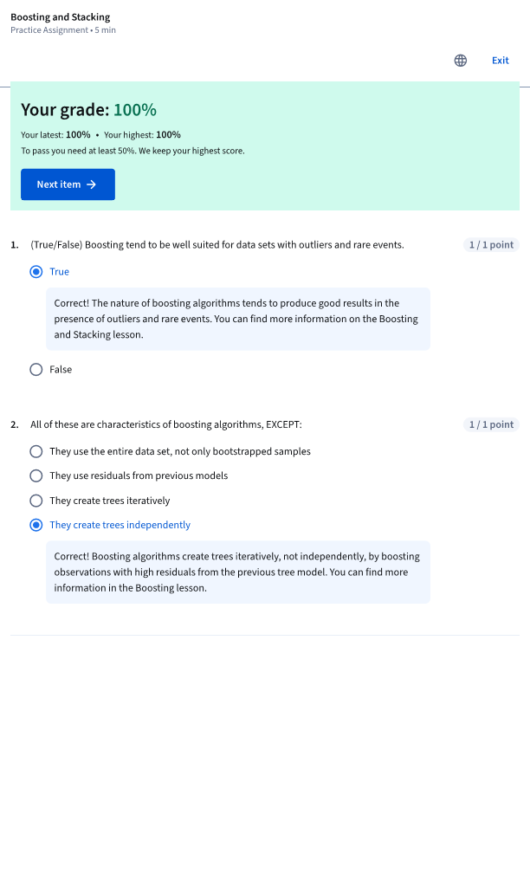

# Module5 _ Boosting and Stacking Labs

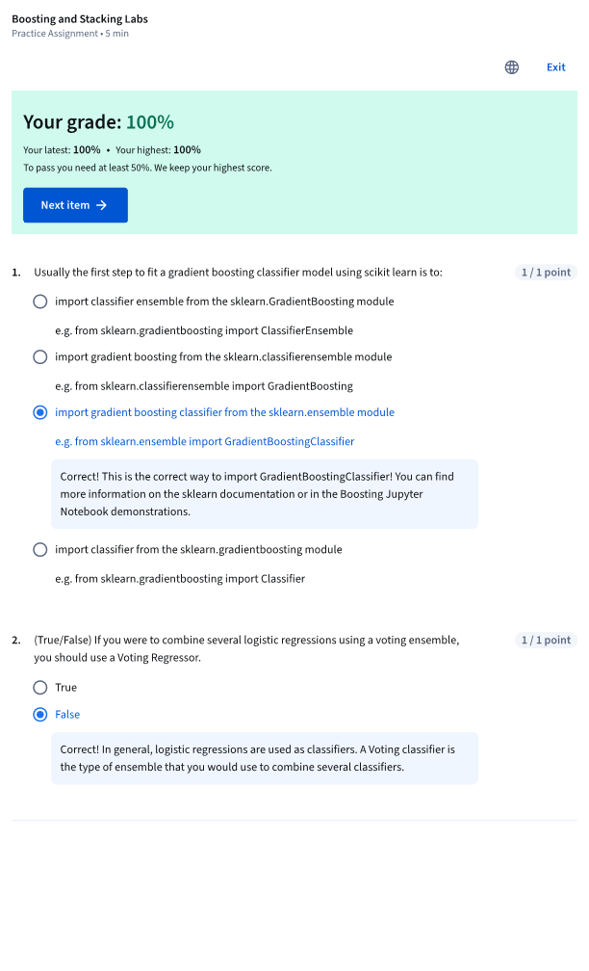

# Module5 _ Graded Quiz

